

Year 12
ATAR
Human Biology

Name:
ANSWERS
Teacher:

Task 10: Mechanisms for Evolution Extended Response |  |  | Weighting 5%
Marks Received | Marks Available | Percentage
 | 20

Time Allocated:
Reading time: 5 minutes
Working time: 25 minutes

Extended answer (20 Marks)

This section has three (3) questions. You must answer two (2) questions. Write your answers on the lined pages provided.

Supplementary pages for the use of planning/continuing your answer to a question have been provided at the end of this Question/Answer booklet. If you use these pages to continue an answer, indicate at the original answer where the answer is continued, i.e. give the page number.

Responses could include clearly labelled diagrams with explanatory notes; lists of points with linking sentences; clearly labelled tables and graphs; and annotated flow diagrams with introductory notes.

Suggested working time: 25 minutes.
_________________________________________________________________________

Question 1 (10 marks)
Archaeologists are extremely lucky when they discover complete fossil specimens. They
normally find only small fragments of fossils. Much of the fossil record is incomplete due to
factors that affect fossil formation and the difficulty in finding fossil specimens.

Explain why the fossil record is important in providing evidence for evolution. Describe the factors that can affect fossil formation and explain why it is difficult to locate fossil specimens.

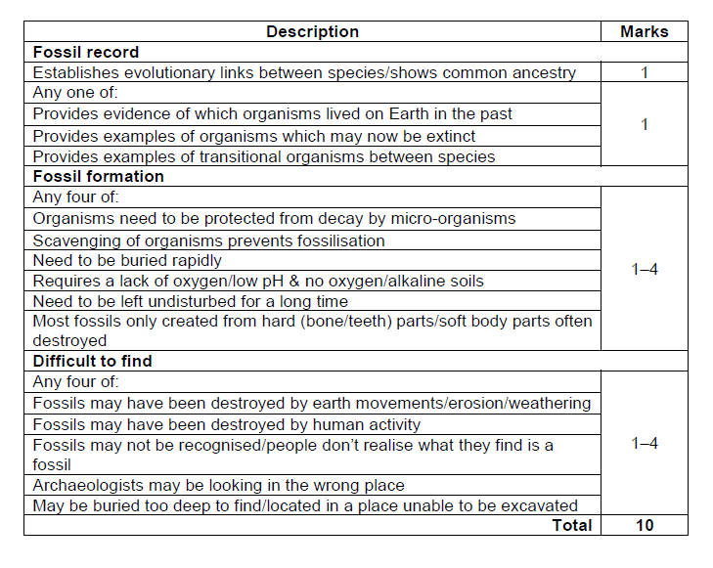

Question 2: (10 marks)
Australian aboriginals migrated to Australia from Africa around 60,000 years ago. Studies have been done into blood group frequencies which show a great variation between the frequencies in Aboriginal and African groups.

Blood Group | African | Aboriginals
O | 48 | 66
A | 27 | 34
B | 21 | 0
AB | 4 | 0

Discuss the likelihood of these differences arising due to natural selection, founder effect or genetic drift.

Description | Marks
Not natural selection as blood groups have no selection pressure | 1
There is no blood group more likely to survive or reproduce than any other | 1
Change in alleles is due to random factors | 1
Founder effect could be a possibility as a population of Aboriginals migrated from Africa | 1
This small population could have had a different allele frequency to the original parent population. | 1
The B allele could have been eliminated as the group left Africa | 1
Unlikely as to eliminate the B allele, both B and AB blood groups would need to have remained behind. | 1
Chance of eliminating an allele is greater in small founder pops | 1
Aboriginals would have been a small population | 1
Genetic Drift is possible as this population has been isolated for a long term | 1
By oceanic geographical barrier | 1
Random chances of alleles being passed to the next generation | 1
Could have eliminated the B allele altogether. | 1
Chance of eliminating an allele is greater in small pops | 1
And the population would have been very small | 1

Question 3: (10 marks)
Examining fossils and their surroundings is one method by which evolution can be shown to have occurred. However there are also many types of comparative studies that can be used to support the theory of evolution.

- Two of these involve studies in biochemistry, namely protein sequences and DNA. Describe the comparative study of DNA and explain how it can be used to provide evidence for evolution. (5 marks)

Description | Marks
Determine the sequence of bases in genome | 1-4
Compare genomes of different species | 1-4
Form hybrid DNA from different species | 1-4
Compare non-coding sequences | 1-4
Compare endogenous retroviruses | 1-4
Compare mitochondrial DNA | 1-4
The more similar the DNA, the more closely related the species | 1
The more different the DNA, the more time has passed since common ancestry. | 1

- Another type of comparative study involves comparing the structural features of related animals. Identify the areas of comparative anatomy and explain, using examples, how it provides evidence for evolution. (5 marks)

Description | Marks
Embryology, homologous organs, vestigial organs | 1
Comparing-early stages of development eg. gill pouches | 1
Comparing similar structures eg. Forelimb are pentadactyl | 1
Comparing stuctures of reduced function eg. wisdom teeth | 1
The more similar the anatomy, the more closely related the species | 1
The more different the anatomy, the more time has passed since common ancestry. | 1

